Vers 2021 STIF Intermediate

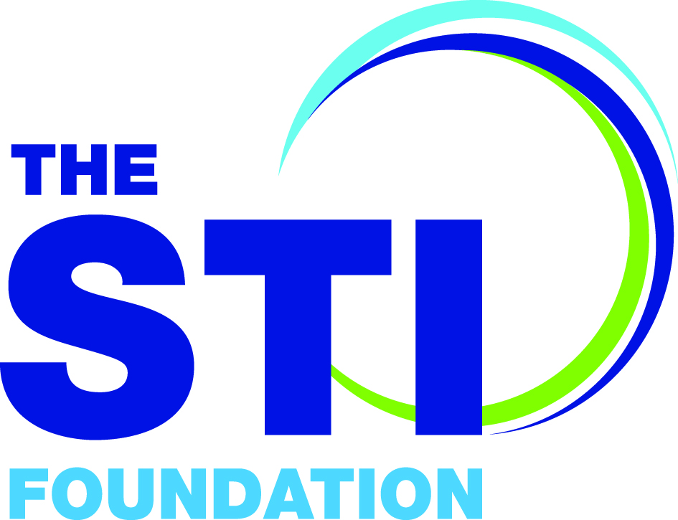

Revalidation

PART A: to be completed by the Revalidation Applicant.

Title (Dr, Mr, Mrs, Ms etc.)
First name
Surname
Job Title
Place of Work
Correspondence address
To which your new certificate will be mailed including postcode

Mobile telephone number
Email address
The date shown on your original Certificate of STIF Intermediate Competency
Name of Original STIF Intermediate Competency Trainer
(as shown on your Certificate of Competency)
IF there is not a Registered STIF Competency Trainer in your location to approve your Revalidation application you can Self Certify. Are you Self Certifying? [ ] YES [ ] NO
IF NO : Please state the Name of the Registered STIF Competency Trainer approving your revalidation application

Are you a current paid-up member of BASHH?
[ ] | Yes
 | Revalidation is free. Please give your BASHH username below.
 | BASHH username:

[ ] | No  Please pay the full registration fee of £60  Please email STIF@bashh.org to arrange payment by BACS or by credit card

1. Clinical experience

In order to maintain skills, Revalidation Applicants should be seeing a minimum of 15 patients/ year with sexual health related problems during the course of their clinical practice. You do not have to submit your evidence with this form, but BASHH reserves the right to request this evidence at any time.
In the case of long term sickness or maternity leave, trainees will need to submit their revalidation application after their return to clinical practice and only when they have met the revalidation criteria in full.

I have evidence that demonstrates that I have been seeing a minimum of 15 patients with sexual health related problems in the last 12 months during the course of my clinical practice.

NAME OF REVALIDATION APPLICANT  Please type here: | SIGNATURE  Sign here:
Date

2. Continued Professional Development

In order to maintain and update their knowledge, Revalidation Applicants should undertake a minimum of 10 hours of CPD in the last 12 months, in areas pertaining to Sexual Health. For medical staff this is equivalent to 10 CPD points.
Please ensure evidence of 10 hours of CPD undertaken in the 12 months preceding revalidation is submitted.

CPD Credit may be derived from:

- Educational events e.g. BASHH OGM/Annual BASHH conference/Masterclass or local/regional events
- Educational tutorials/courses (both in-house and external)
- Self-directed e-learning modules e.g. e-learning for healthcare sessions from eHIV-STI, doctors.net sexual health modules
- Reading Journal articles pertaining to sexual health

Not all CPD can comprise self-directed learning. At least 5% must be acquired through departmental, regional or national educational events/tutorials or courses.

………..continued/….

Please list the CPD you have undertaken in the 12 months preceding revalidation and accompany each entry with (approx.) 100 word learning reflection.
For example:

Date, Title and reflection | Type of CPD | No. of Hours
01/01/2014 “Herpes serology: To do or not to do – that is the question”  Short reflection on the presentation that you attended e.g. what you learnt from it and how it might change your practice. | Departmental presentation | 1
02/02/2014 BASHH Afternoon OGM: Title  Short reflection on the meeting that you attended e.g. what you learnt from it and how it might change your practice. | National educational meeting | 3
03/03/2014 Int J STD AIDS 2013 24: 593 Title  Short reflection on the article that you read e.g. what you learnt from it and how it might change your practice. | Journal article | 0.5

Date, Title and reflection | Type of CPD | No. of Hours
Date, Title and reflection | Type of CPD | No. of Hours
IF you need additional space to list your CPD, please copy and insert extra pages as needed

3. Audit

Please give a brief description of a clinical audit relating to sexual health care that you have personally completed within the last five years.
- The audit you present should demonstrate that as an investigator you can manage data collection, interpretation and where appropriate should indicate how it will influence clinical practice or clinic management.
- The Registered STIF Competency Trainer approving your application needs to sign below to confirm that your audit meets the criteria.
- If self-certifying, please sign to indicate that your audit meets the criteria.

A summary of the audit should be included in your paperwork. This should be structured as follows:
  - Background
  - Objectives
  - Standards
  - Sample
  - Data source(s)
  - Key findings
  - Results
  - Conclusions
  - Recommendations (including recommendations for re-audit)

Registered STIF Competency Trainer SIGNATURE : DATE:

Self certifying: I confirm that my audit meets the specified criteria
Signed: DATE:

PART B: To be completed by (any) Registered STIF Intermediate Competency Trainer:

The Revalidation Applicant’s logbook may not cover all the competencies seen below, in which case you may want to discuss the topic with them or undertake a formal observed assessment or CBD so that you are confident that the trainee remains competent in this area.
I have seen evidence that demonstrates that the above-named individual has been seeing a minimum of 15 patients per year with sexual health related problems during the course of his/her clinical practice. The audit meets the required criteria.
I confirm that the applicant remains competent in the following STIF Intermediate Competencies:
(Please tick)
Sexual history taking and management of men and women, including young people and men who have sex with men
Genital examination of men and women (excluding bimanual pelvic examination)
Consultations with patients with limited English proficiency *
Consulting by Phone/Video *
Risk reduction and Sexual Health Promotion
Partner notification
Managing women who present with Unwanted/Unplanned Pregnancy *
Diagnosis and management of genital tract infections (chlamydia, gonorrhoea, trichomonas, mycoplasma)
Management of vaginal discharge
Management of male urethral discharge
Management of genital warts and molluscum contagiosum
Management of urinary tract infection
Management of genital infestations
Management of genital ulcer disease due to Herpes Simplex Virus
Screening and prevention of hepatitis A, B, C
Assessment and management of need for PEPSE
ARV as prevention (PrEP and TASP) *
HIV pre- and post-test discussion
Assessment of the patient who reports a sexual assault
Domestic Violence and abuse
Safeguarding Children
Female Genital Mutilation
Psychosexual problems *
Trans and non-binary awareness *

* = topics which have been added to STIF Intermediate in the past 2-3 years so which may not have been covered in your original STIF Intermediate Competency assessments. If you would like to formally record assessments for these, please contact the STIF secretariat stif@bashh.org

Extract: GMC Guidance “Good Medical Practice”
Maintaining Trust: Communicating information
71. You must be honest and trustworthy when writing reports, and when completing or signing forms, reports and other documents.¹⁶ You must make sure that any documents you write or sign are not false or misleading.
Extract: NMC Code 2015 for Registered Nurses
In relation to assessments, registered nurses must ‘complete all records at the time or as soon as possible after the event’ (10.1: p9) ensuring that they ‘complete all records accurately and without any falsification, taking immediate and appropriate action if (they) become aware that someone has not kept to these requirements’ (10.3: p9).

Registered STIF Intermediate Competency Trainer NAME - Please print

SIGNATURE : DATE:

PART C: Self-certification route : To be completed in absence of local Registered STIF Competency Trainer :
Candidates who need to self-certificate should use the reflection form(below) to provide written evidence. The cases should be examples of management of the below topics during their clinical practice. Candidates need only to see one patient that demonstrates their knowledge and skills related to each of the core competencies listed; it is also recognised that a single consultation may cover one or more of the competencies.

I confirm that I remain competent in the following STIF Intermediate Competencies:
(Please tick)

Sexual history taking and management of men and women, including young people and men who have sex with men
Genital examination of men and women (excluding bimanual pelvic examination)
Consultations with patients with limited English proficiency *
Consulting by Phone/Video *
Risk reduction and Sexual Health Promotion
Partner notification
Managing women who present with Unwanted/Unplanned Pregnancy *
Diagnosis and management of genital tract infections (chlamydia, gonorrhoea, trichomonas, mycoplasma)
Management of vaginal discharge
Management of male urethral discharge
Management of genital warts and molluscum contagiosum
Management of urinary tract infection
Management of genital infestations
Management of genital ulcer disease due to Herpes Simplex Virus
Screening and prevention of hepatitis A, B, C
Assessment and management of need for PEPSE
ARV as prevention (PrEP and TASP) *
HIV pre- and post-test discussion
Assessment of the patient who reports a sexual assault
Domestic Violence and abuse
Safeguarding Children
Female Genital Mutilation
Psychosexual problems *
Trans and non-binary awareness *

* = topics which have been added to STIF Intermediate in the past 2-3 years so which may not have been covered in your original STIF Intermediate Competency assessments. If you would like to formally record assessments for these, please contact the STIF secretariat stif@bashh.org

Extract: GMC Guidance “Good Medical Practice”
Maintaining Trust: Communicating information
71. You must be honest and trustworthy when writing reports, and when completing or signing forms, reports and other documents.¹⁶ You must make sure that any documents you write or sign are not false or misleading.
Extract: NMC Code 2015 for Registered Nurses
In relation to assessments, registered nurses must ‘complete all records at the time or as soon as possible after the event’ (10.1: p9) ensuring that they ‘complete all records accurately and without any falsification, taking immediate and appropriate action if (they) become aware that someone has not kept to these requirements’ (10.3: p9).

SELF CERTIFICATION REVALIDATION APPLICANT SIGNATURE

DATE

Self-certification PLEASE USE THE FORM BELOW to provide evidence of management for all STIF Intermediate competencies – copy and reprint as needed

STIF COMPETENCY  demonstrated | Type in STIF competency/competencies being demonstrated in consultation

What happened?

What was I thinking? Feeling?

What was good, what was bad about the experience?

What sense can I make of the situation?

What other options are there that I could have done?

What will I do next time if this arises?

Action planning based on this

Signed……….……………………………………………………….............. Date………………………………………….

PLEASE SEND THE COMPLETED FORM to
BASHH STIF SECRETARIAT
STIF@bashh.org

retaining a copy for your records

Additional pages for CPD listing

Date, Title and reflection | Type of CPD | No. of Hours

Date, Title and reflection | Type of CPD | No. of Hours

Date, Title and reflection | Type of CPD | No. of Hours

PLEASE SEND THE COMPLETED FORM
retaining a copy for your records
BASHH STIF SECRETARIAT
STIF@bashh.org

C/O Executive Business Support Ltd, City Wharf, Davidson Road, Lichfield, Staffordshire WS14 9DZ
Tel: 01543 442190

