rev Mar21

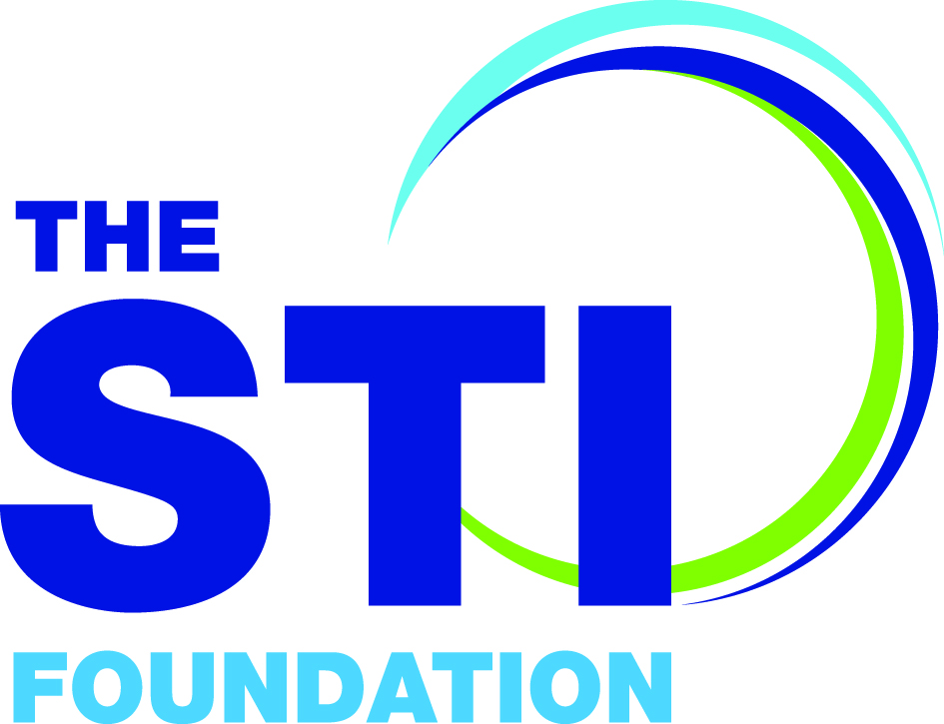
Revalidation

PART A: to be completed by the Revalidation Applicant.

Title (Dr, Mr, Mrs, Ms etc.)
First name
Surname
Job Title
Place of Work
Correspondence address
To which your new certificate will be mailed including postcode

Your Mobile telephone number
Your Email address
The date shown on your original STIF Certificate of SHA Competency
Name of Original STIF SHA Competency Trainer
(as shown on your Certificate of Competency)
Name of Registered (Senior HA) SHA Trainer or Registered STIF Competency Trainer in the absence of a Registered SHA Trainer
Registered STIF Competency Trainer email address

Are you a current paid-up member of BASHH?

[ ] | Yes
 | Revalidation is free. Please give your BASHH username below.
 | BASHH username:

[ ] | No  Please pay the full registration fee of £60  Email STIF@BASHH.org to arrange payment by BACS or PayPal

1. Clinical experience

In order to maintain skills, Revalidation Applicants should be seeing a minimum of 15 patients/ year with sexual health related issues during the course of their clinical practice.
You do not have to submit your evidence with this form, but BASHH reserves the right to request this evidence at any time.

I have evidence that demonstrates that I have been seeing a minimum of 15 patients with sexual health related issues in the last 12 months during the course of my clinical practice.

REVALIDATION APPLICANT SIGNATURE
Date

2. Continued Professional Development

In order to maintain and update their knowledge, Revalidation Applicants should undertake a minimum of 10 hours of CPD in the last 12 months, in areas pertaining to Sexual Health. For medical staff this is equivalent to 10 CPD points.

Please ensure evidence of 10 hours of CPD undertaken in the 12 months preceding revalidation is submitted.

CPD Credit may be derived from:

- Educational events e.g. BASHH OGM/Annual BASHH conference/Masterclass or local/regional events/SSHA conference/SSHA study days
- Educational tutorials/courses (both in-house and external)
- Self-directed e-learning modules e.g. e-learning for healthcare sessions from eHIV-STI, doctors.net sexual health modules
- Reading Journal articles pertaining to sexual health

Not all CPD can comprise self-directed learning. At least 5% must be acquired through departmental, regional or national educational events/tutorials or courses.

………..continued/….

Please list the CPD you have undertaken in the 12 months preceding revalidation and accompany each entry with (approx.) 100 word learning reflection.
For example:

Date, Title and reflection | Type of CPD | No. of Hours
01/01/2014 “Herpes serology: To do or not to do – that is the question”  Short reflection on the presentation that you attended e.g. what you learnt from it and how it might change your practice. | Departmental presentation | 1
02/02/2014 BASHH Afternoon OGM: Title  Short reflection on the meeting that you attended e.g. what you learnt from it and how it might change your practice. | National educational meeting | 3
03/03/2014 Int J STD AIDS 2013 24: 593 Title  Short reflection on the article that you read e.g. what you learnt from it and how it might change your practice. | Journal article | 0.5

Date, Title and reflection | Type of CPD | No. of Hours
Date, Title and reflection | Type of CPD | No. of Hours
IF you need additional space to list your CPD, please copy and insert extra pages as needed

3. Audit

Please give a brief description of a clinical audit relating to sexual healthcare that you have personally completed within the last five years. The audit you present should demonstrate that as an investigator you can manage data collection, interpretation and where appropriate should indicate how it will influence clinical practice or clinic management.

- The Registered STIF Competency Trainer approving your application needs to sign below to confirm that your audit meets the criteria.
- If self-certifying, please sign to indicate that your audit meets the criteria.

Registered STIF Competency Trainer SIGNATURE : DATE:

Self-certifying: I confirm that my audit meets the specified criteria
Signed: DATE:

PART B: To be completed by Registered (Senior HA) SHA Trainer or any Registered STIF Competency Trainer in the absence of a Registered SHA Trainer:

The Revalidation Applicant’s revalidation logbook may not cover all the competencies seen below, in which case you may want to discuss the topic with them or undertake a formal CBD so that you are confident that the trainee remains competent in this area.

I have seen evidence that demonstrates that the above named individual has been seeing a minimum of 15 patients per year with sexual health related issues during the course of his/her clinical practice.

The audit meets the required criteria.

I confirm that the applicant remains competent in the following STIF SHA Competencies:
(Please tick)

- Assessment and management of a woman including giving appropriate advice on safer sex, preventing STIs & unplanned pregnancy
- Assessment and management of a heterosexual man including giving appropriate advice on safer sex, preventing STIs
- Assessment and management of a man who has sex with other men (MSM) including giving appropriate advice on safer sex, preventing STIs
- Assessment and management of young people (under 18) including giving appropriate advice on safer sex, preventing STIs and assessment for indicators of exploitation/grooming
- Partner Notification: Conducting partner notification for relevant STIs and HIV including negotiating plan, PN resolution and completing a Provider Referral
- Risk Reduction including Safer Sex Advice, using MI skills in practice and the role of alcohol, recreational/club drugs in risk-taking behaviour
- Assessment of need for Post Exposure Prophylaxis following Sexual Exposure to prevent HIV acquisition and refer / manage appropriately
- Managing an appropriate HIV pre & post-test discussion, including giving results to a patient at "High Risk"
- Undertaking a consultation when the patient has limited English proficiency
- Undertaking a consultation by phone/video
- Undertaking a consultation with a Trans patient

/continued….

I also confirm that the above healthcare professional has been assessed as having sufficient knowledge in the following areas:

- Assessment and management of people at higher risk who are especially vulnerable to STIs and other sex-related areas
- Psychological support in key areas such as sexual assault, health anxiety, a new HIV diagnosis and herpes simplex infection.
- Legal and Ethical Issues in clinical practice including partner notification issues, pregnancy choices, criminalisation of STI/HIV transmission and non-disclosure
- The Public Health role and responsibilities associated with working as a Sexual Health Adviser
- Performing an audit in an area relevant to health adviser clinical practice

PLEASE NOTE:

Extract: GMC Guidance “Good Medical Practice”
Maintaining Trust: Communicating information
71. You must be honest and trustworthy when writing reports, and when completing or signing forms, reports and other documents.¹⁶ You must make sure that any documents you write or sign are not false or misleading.
Extract: NMC Code 2015 for Registered Nurses
In relation to assessments, registered nurses must ‘complete all records at the time or as soon as possible after the event’ (10.1: p9) ensuring that they ‘complete all records accurately and without any falsification, taking immediate and appropriate action if (they) become aware that someone has not kept to these requirements’ (10.3: p9).

Registered STIF or SHA Competency Trainer
SIGNATURE

DATE

PART C: To be completed in absence of a local Registered STIF Competency Trainer : Self-certification route

Candidates who need to self-certificate can download and use the reflection form to provide written evidence. The cases should be examples of management of the below topics during the course of their clinical practice. Candidates need only to see one patient that demonstrates their knowledge and skills related to each of the core competencies listed; it is also recognised that a single consultation may cover one or more of the competencies.

PLEASE NOTE BELOW EXTRACTS from Codes of Conduct

Extract: GMC Guidance “Good Medical Practice”
Maintaining Trust: Communicating information
71. You must be honest and trustworthy when writing reports, and when completing or signing forms, reports and other documents.¹⁶ You must make sure that any documents you write or sign are not false or misleading.

Extract: NMC Code 2015 for Registered Nurses
In relation to assessments, registered nurses must ‘complete all records at the time or as soon as possible after the event’ (10.1: p9) ensuring that they ‘complete all records accurately and without any falsification, taking immediate and appropriate action if (they) become aware that someone has not kept to these requirements’ (10.3: p9).

I confirm that I remain competent in the following STIF SHA Competencies:

- Assessment and management of a woman including giving appropriate advice on safer sex, preventing STIs & unplanned pregnancy
- Assessment and management of a heterosexual man including giving appropriate advice on safer sex, preventing STIs
- Assessment and management of a man who has sex with other men (MSM) including giving appropriate advice on safer sex, preventing STIs
- Assessment and management of young people (under 18) including giving appropriate advice on safer sex, preventing STIs and assessment for indicators of exploitation/grooming
- Partner Notification: Conducting partner notification for relevant STIs and HIV including negotiating plan, PN resolution and completing a Provider Referral
- Risk Reduction including Safer Sex Advice, using MI skills in practice and the role of alcohol, recreational/club drugs in risk-taking behaviour
- Assessment of need for Post Exposure Prophylaxis following Sexual Exposure to prevent HIV acquisition and refer / manage appropriately
- Managing an appropriate HIV pre & post-test discussion, including giving results to a patient at "High Risk"
- Undertaking a consultation when the patient has limited English proficiency
- Undertaking a consultation by phone/video
- Undertaking a consultation with a Trans patient

I confirm that I have maintained my knowledge in the following areas:
- Assessment and management of people at higher risk who are especially vulnerable to STIs and other sex-related areas
- Psychological support in key areas such as sexual assault, health anxiety, a new HIV diagnosis and herpes simplex infection.
- Legal and Ethical Issues in clinical practice including partner notification issues, pregnancy choices, criminalisation of STI/HIV transmission and non-disclosure
- The Public Health role and responsibilities associated with working as a Sexual Health Adviser
- Performing an audit in an area relevant to health adviser clinical practice

SELF CERTIFICATION REVALIDATION APPLICANT SIGNATURE

DATE

Continued/……

PLEASE USE THE FORM BELOW to provide evidence of STIF SHA Competency management for all competencies - form to be completed for each competency demonstrated

STIF COMPETENCY  demonstrated | Type in STIF competency/competencies being demonstrated in consultation

What happened?

What was I thinking? Feeling?

What was good, what was bad about the experience?

What sense can I make of the situation?

What other options are there that I could have done?

What will I do next time if this arises?

Action planning based on this

Signed……….……………………………………………………….............. Date………………………………………….

PLEASE SCAN and EMAIL THE COMPLETED REVALIDATION FORM

To STIF@BASHH.org

retaining a copy for your records

